Contents
Black Locust ‘Purple Robe’ 2
River Birch 3
Seven-Son Flower 4
Ohio Buckeye 5
Linden ‘Greenspire’ 6
Maackia amurensis 7
London Plane Tree ‘Bloodgood’ 8

Black Locust ‘Purple Robe’
Robinia ‘Purple Robe’

Height: 40 feet
Spread: 30 feet
Sunlight:
Hardiness Zone: 4a
Other Names: Common Locust

Description:
- North American species
- grow to be about 40 feet tall at maturity, with a spread of 30 feet.
- deciduous tree with a more or less rounded form and has low canopy with a typical clearance of 5 feet from the ground
- It grows at a fast rate, and under ideal conditions can be expected to live for 60 years or more.
- extremely adaptable, performs well in poor soils; more compact than the species

Ornamental Features:
- bluish-green foliage which emerges burgundy in spring
- oval pinnately compound leaves turn yellow in fall
- has chains of fragrant deep pink pea-like flowers with yellow eyes hanging below the branches in late spring
- fruit are smooth, flat purple-brown pods of up to 4 inch long
- furrowed black bark

Culture:

- best in full sun to partial shade
- very adaptable to both dry and moist growing conditions, but will not tolerate any standing water
- considered to be drought-tolerant, and thus makes an ideal choice for xeriscaping or the moisture-conserving landscape
- not particular as to soil type or pH, and is able to handle environmental salt
- highly tolerant of urban pollution and will even thrive in inner city environments
- spreads by root suckers

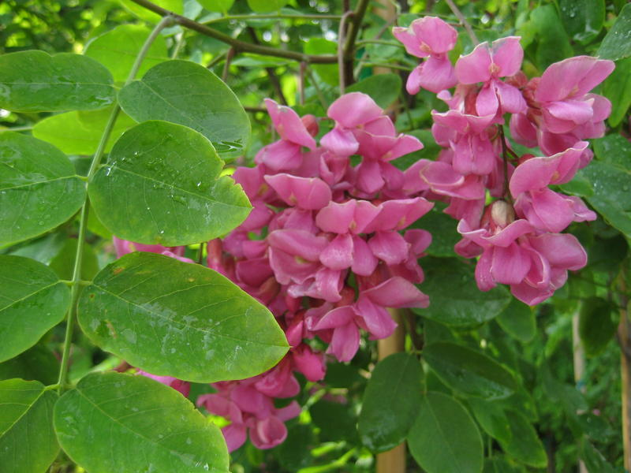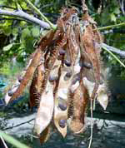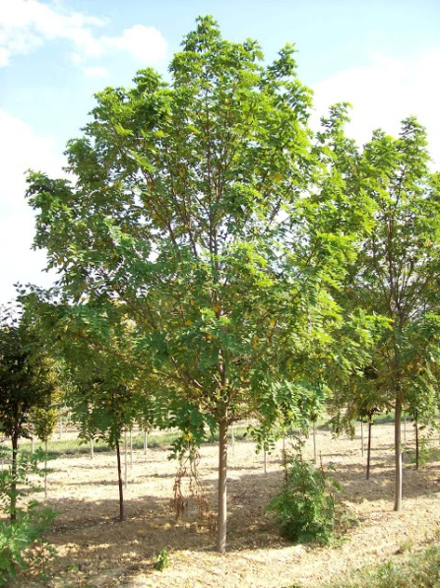

River Birch
Betula Nigra

Height: 60 feet
Spread: 45 feet
Sunlight:
Hardiness Zone: 3b
Other Names: Red Birch

Description:
- deciduous trees grow to be about 60 feet tall at maturity, with a spread of 45 ft; often multiple trunks
- has a low canopy with a typical clearance of 3 feet from the ground
- under ideal conditions can be expected to live for 70 years or more.
Ornamental Features:
- diamond shapped, double toothed leaves on erect or spreading canopy
- dark green foliage throughout the season, turn yellow in the fall
- Monoecious flowers appear in drooping, brownish male catkins (fall) and smaller, upright, greenish female catkins (spring)
- Female catkins become fruit in summer. The fruit is a cone that is a little over an inch long and is filled with hairy seeds.
- amazing peeling bark in colors of white, brown and tan
Culture:
- tree does best in full sun to partial shade
- quite adaptable, prefering to grow in average to wet conditions, and will even tolerate some standing water
- not particular as to soil type, but has a definite preference for acidic soils, and is subject to chlorosis (yellowing) of the leaves in alkaline soils
- highly tolerant of urban pollution and will even thrive in inner city environments. Consider applying a thick mulch around the root zone in winter to protect it in exposed locations or colder zones

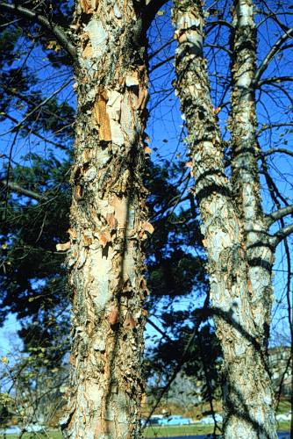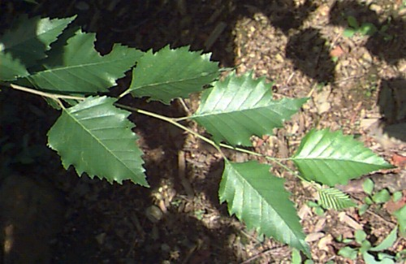

Seven-Son Flower
Heptacodium miconioides

Height: 15 feet
Spread: 12 feet
Sunlight:
Hardiness Zone: 6a
Habitat:
- native to China and considered rare

Description:
- a deciduous large shrub or small tree - multi-stemmed or single-stemmed
- upright branching and growth
- develops a loose, rounded or irregular crown

Ornamental Features:
- simple, deciduous leaves, opposite leaf arrangement, leaves are 2" to 6" long and about half as wide, rounded base and acuminate tip
- leaves have 3 parallel main veins; forest green foliage which emerges lime green in spring; no fall colour
- panicles of fragrant creamy white flowers at the ends of the branches from late summer to mid fall
- fuschia coloured calyces in fall,
- appealing exfoliating bark of gray, brown-red, tan, cream colours

Culture:
- full sun to partial shade
- soil adaptable, prefers moist well-drained fertile soil
- easily transplanted and grown
- propagation by cuttings and seeds

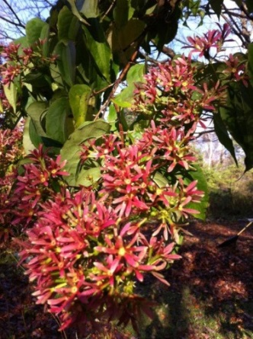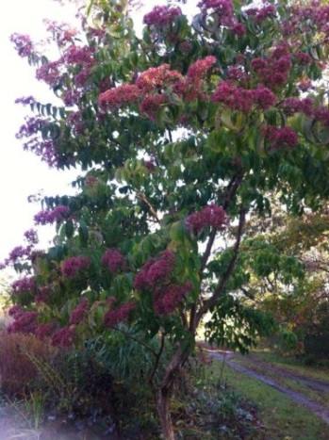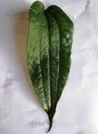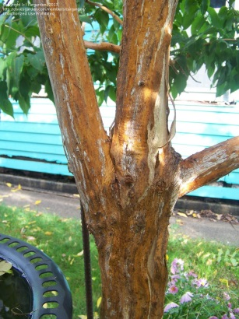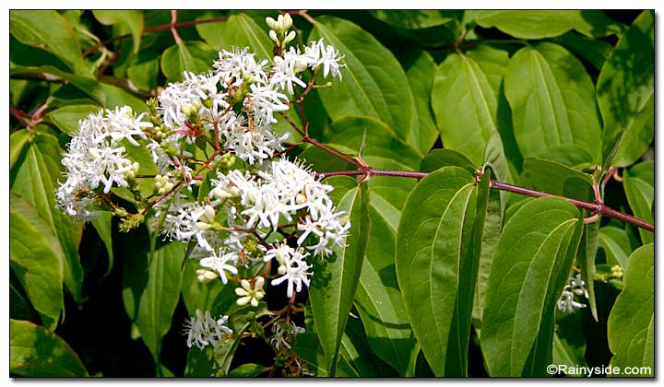

Ohio Buckeye
Aesculus glabra

Height: 35 feet
Spread: 35 feet
Sunlight:
Hardiness Zone: 2b
Habitat:
- Native southeast and central US
- Also found locally in southwest of Ontario, on Walpole Island in Lake St. Clair,

Description:
- medium shade tree; deciduous; usually under 30' tall, but can grow to 70' or taller
- broad, rounded crown, with very dense, low branches
- droop and swoop branching limbs grow toward ground, then curve up at tips
- furrowed gray bark

Ornamental Features:
- opposite, palmately-compound leaves, with 5 leaflets, emerging light green then becoming dark green
- yellow to red-brown or orange fall colour
- blooms in mid-May -panicles 4" to 7" long; individual greenish-yellow flowers, 1" wide
- fruit of light brown prickly capsule with single poisonous? Seed which attacts squirrels

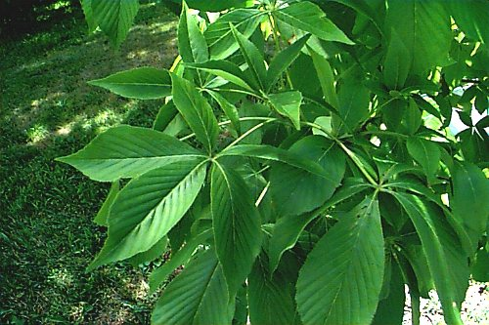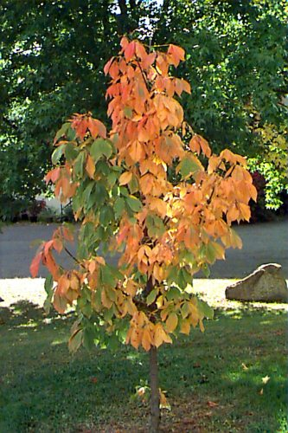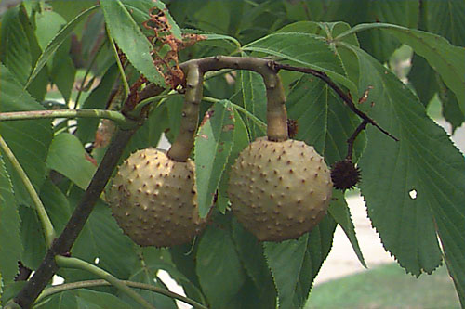

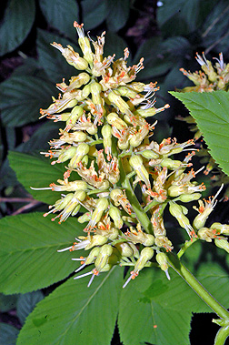

Linden ‘Greenspire’
Tilia cordata
Height: 50 feet
Spread: 30 feet
Sunlight:
Hardiness Zone: 3
Other Names: Littleleaf Linden, Lime, Smallleaf Lime. This is a selected variety of a species not originally from North America.
Description:
- dense deciduous tree with a strong central leader and a distinctive and refined pyramidal form
- grow to be about 50 feet tall at maturity, with a spread of 30 feet. It has a high canopy with a typical clearance of 6 feet from the ground
- grows at a medium rate, and under ideal conditions can be expected to live for 70 years or more.
Ornamental Features:
- Greenspire Linden has dark green foliage throughout the season
- heart-shaped leaves turn an outstanding gold in the fall
- subtle clusters of fragrant yellow flowers with tan bracts hanging below the branches in early summer
- fruit is not ornamentally significant
- rough gray bark
Culture:
- This is a relatively low maintenance tree, and is best pruned in late winter once the threat of extreme cold has passed
- good choice for attracting bees to your yard
- This tree should only be grown in full sunlight
- very adaptable to both dry and moist locations
- not particular as to soil type or pH and is highly tolerant of urban pollution and will even thrive in inner city environments.

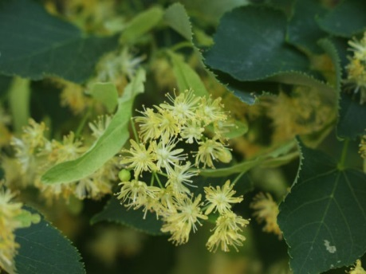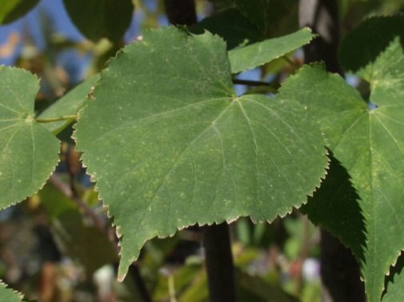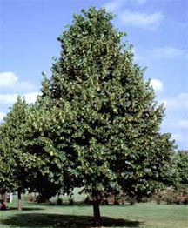

Maackia amurensis

Height: 25 feet
Spread: 30 feet
Sunlight:
Hardiness Zone: 3a

Habitat:
- Native to Manchuria

Description:
- grow to be about 25 feet tall at maturity, with a spread of 30 feet; foliage mostly toward the outer part of the canopy
- deciduous small rounded shape tree with short main trunk that splits into many main branches 2' to 3' from the ground
- no autumn color develops
Ornamental Features:
- small dull, white fragrant pea-like flowers in upright clusters of 4" to 6" long in June and July
- fruit of 2" to 3" long flat pod, changes from green to brown
- bark exfoliates in curls; color is an interesting amber or copper color with greenish undertones
- bark that isn't exfoliating is shiny and looks as if it were varnished

Culture:
- Best grown in full sun
- seems to prefer loose, well-drained soils, soil pH is not an important factor
- adaptable to both dry and moist locations
- able to handle environmental sal and is somewhat tolerant of urban pollution
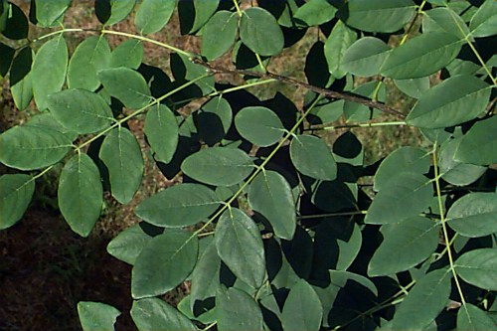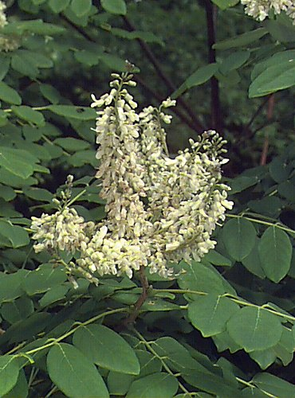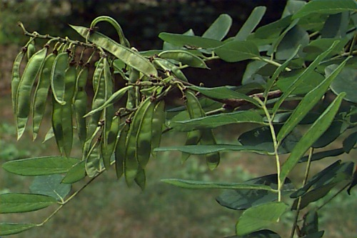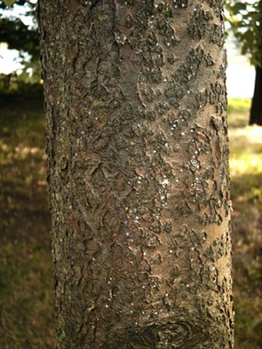

London Plane Tree ‘Bloodgood’
Platanus Acerifolia
Height: 14-16 m
Spread: 10-13 m
Sunlight:
Hardiness Zone: 5
Other Names: sycamore
Description:
- straight trunk and a large open crown
- pyramidal when young, becoming rounded to spreading with age

Ornamental Features:
- bark has a distinctive camouflage pattern created as patches of green or brown outer bark flake off (exfoliate) to expose cream-coloured inner bark
- Leaves are palmately lobed like a maple leaf with 3 to 5 main lobes, the central lobe usually longer than wide. Leaves arranged alternately on branch while maples have opposite branching. In fall leaves turn yellow-brown
- Flowers are tiny, borne in round clusters. Female flowers are red, while male flowers are green
- Fruits are in aggregates of hundreds in a round ball. Two, sometimes 3, aggregates are borne on a single stalk
- Twigs are zig-zagged and hairy. Lateral buds are angled at about 45 degrees from the twig.
Culture:
- easily grown in average, medium to wet, well-drained soils in full sun. Tolerates light shade. Prefers rich, humusy, consistently moist soils
- Generally tolerant of most urban pollutants.

