Spring Show
Date: May 22
Speaker: Ingrid Janssen

DIVISON I HORTICULTURE

All specimen classes are OPEN; you may enter TWO ITEMS but they must be different cultivars. Exception to this rule will be specified where applicable.

Section ‘A’ Tulips
- 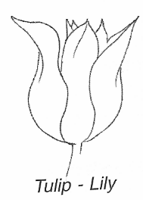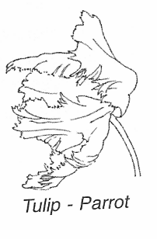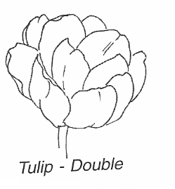Show with only 2 leaves
- Tulip, Single red 1 bloom
- Tulip, Single yellow. 1 bloom
- Tulip, Single pink 1 bloom
- Tulip, Single purple 1 bloom
- Tulip, Single white 1 bloom
- Tulip, Single, Any other colour(s) 1 bloom
- Tulip, Double, any colour 1 bloom
- Tulip, Lily-type, any colour 1 bloom
- Tulip, Fringed, any colour 1 bloom
- Tulip, Parrot, any colour 1 bloom
- Tulip, Multiflora (2-8 blooms on one stem) 1 stem
- Tulip, Viridiflora 1 bloom
- Tulip, Any other cultivar 1 bloom
- Tulip, collection, 3 different cultivars 3 blooms/stems

Section ‘B’ Other Specimens
- Allium, 1 cultivar 1 stem
- Bleeding Heart… UNDER 60 cm / 24” 1 branch
- Foliage, (from any plant) (NIP) 1 stem
- Heuchera, 1 cultivar 3 leaves
- Hosta solid colour 1 leaf
- Hosta variegated 1 leaf
- Iris, Medium Bearded, 1 cultivar 1 stalk
- Iris, Miniature Dwarf Bearded,1 cultivar 3 stalks
- Iris, Any other cultivar 1 stalk
- Narcissus, white any type, UNLIMITED ENTRIES 1 scape
- Narcissus, yellow any type, UNLIMITED ENTRIES 1 scape
- Narcissus, Bicolour any type, UNLIMITED ENTRIES 1 scape
- Narcissus, Double any type, UNLIMITED ENTRIES 1 scape
- Pansy, any colour 3 stems
- Peony, any type (NIP) 1 bloom
- Tree Peony, any colour 1 bloom
- Solomon Seal, UNDER 76 cm / 30” 1 stem
- Viola, (Johnny Jump Up) 3 stems
- Any Native Ephemeral (must be garden grown) 1 bloom/1 stem
- Any other bulb, corm, rhizome or tuber (NIP) 1 bloom
- Any other bulb, corm, rhizome or tuber (NIP) 1 stem
- Any other perennial (NIP) 1 bloom
- Any other perennial (NIP) 1 stem

Section ‘C’ Branches of Trees, Shrubs and Vines
Lilac branches – maximum. size 60 cm / 24”
- Lilac, Single white 1 branch
- Lilac, Single light purple 1 branch
- Lilac, Single dark purple 1 branch
- Lilac, Single, any other colour 1 branch
- Lilac, Double, white 1 branch
- Lilac, Double, any other colour 1 branch
- Lilac Collection, 3 different cultivars 3 branches
- Any other flowering branch / vine UNDER 76 cm / 30” (NIP) 1 branch
- Any branch / vine showing only foliage, UNDER 76 cm / 30” (NIP) 1 branch

Section ‘D’ Container Grown Plants
Refer to ‘Houseplants’ in Definition of terms. All classes are Open.

- Plant grown for foliage max. pot size 25cm / 10” (NIP) 1 pot
- Plant grown for bloom max. pot size 25cm / 10” (NIP) 1 pot

Section ‘E’ Vegetables
- Asparagus, uniform in width & length & approx. 20 cm” In length 3 stalks
- Rhubarb, 1 cultivar, pull, do not cut stalks, top to 5cm in a fan 3 stalks
- Any other vegetable/herb, 1 cultivar, UNLIMITED ENTRIES suitable #

DIVISION II DESIGN

Only the Pick and Plunk classes in Special Exhibits are OPEN.

Section ‘F’
Where possible, please provide the name(s) of a plant material used in your design.

- “Unrestrained” Foliage design (refer to Definition of Terms)
- “Luminous” Design of choice
- You create a title An interpretation of your own title. Display a title card.

Special Exhibits
Please refer to ‘Pick and Plunk’ in the section under Definition of Terms.

- Pick and plunk Under 15cm / 6”
- Pick and plunk 15 – 30cm / 6-12”
- Pick and plunk Over 30cm / 12”

DIVISION III PHOTOGRAPHY*.

- Spring Fever
- Blossoming

* See October’s Pumpkins, Pies and Pictures section for photography rules.
Best in Show for the 2023 Spring Show

Best of Tulip Specimen Ken Brown
Best Specimen (other than Tulip) Ken Brown
Best Branch Sherry Howard
Best Container Grown Plant Helen Ecker
Best Vegetable Ken Brown
Best Design Sherry Howard
Best Special Exhibit Sherry Howard
Best Photography Helen Ecker

