**WORKSHOP REGISTRATION FORM**

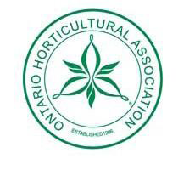 Ontario Horticultural Association District 17 Annual General Meeting

Bowmanville Horticultural Society

CORDIALLY INVITES

The Membership of District 17, OHA

TO ATTEND

The 2018 Annual General Meeting

Date Saturday April 21, 2018

Location Faith United Church, 1778 Nash Road, Courtice, Ontario L1E 2L9

Workshop Time 1:00 pm

**BEEHIVE CONSTRUCTION WORKSHOP**

Registration Deadline **Friday April 6, 2018** …………………… $10.00 per participant

Registration Includes:

Building Materials to complete the workshop

**Payment**

Cheques payable to Bowmanville Horticultural Society

Cheques and registration form to be handed in at Presidents Meeting on **Saturday April 7, 2018**

Registration Form to be completed by the Society President

Only 2 Participants per Society = Total of 24 Participants

**Society:**

Name(s) of Participant **Please Print Telephone Email**

1.

2.

Backup Person - if one does not attend

3.

BHS Version 1 – Feb. 4, 2018