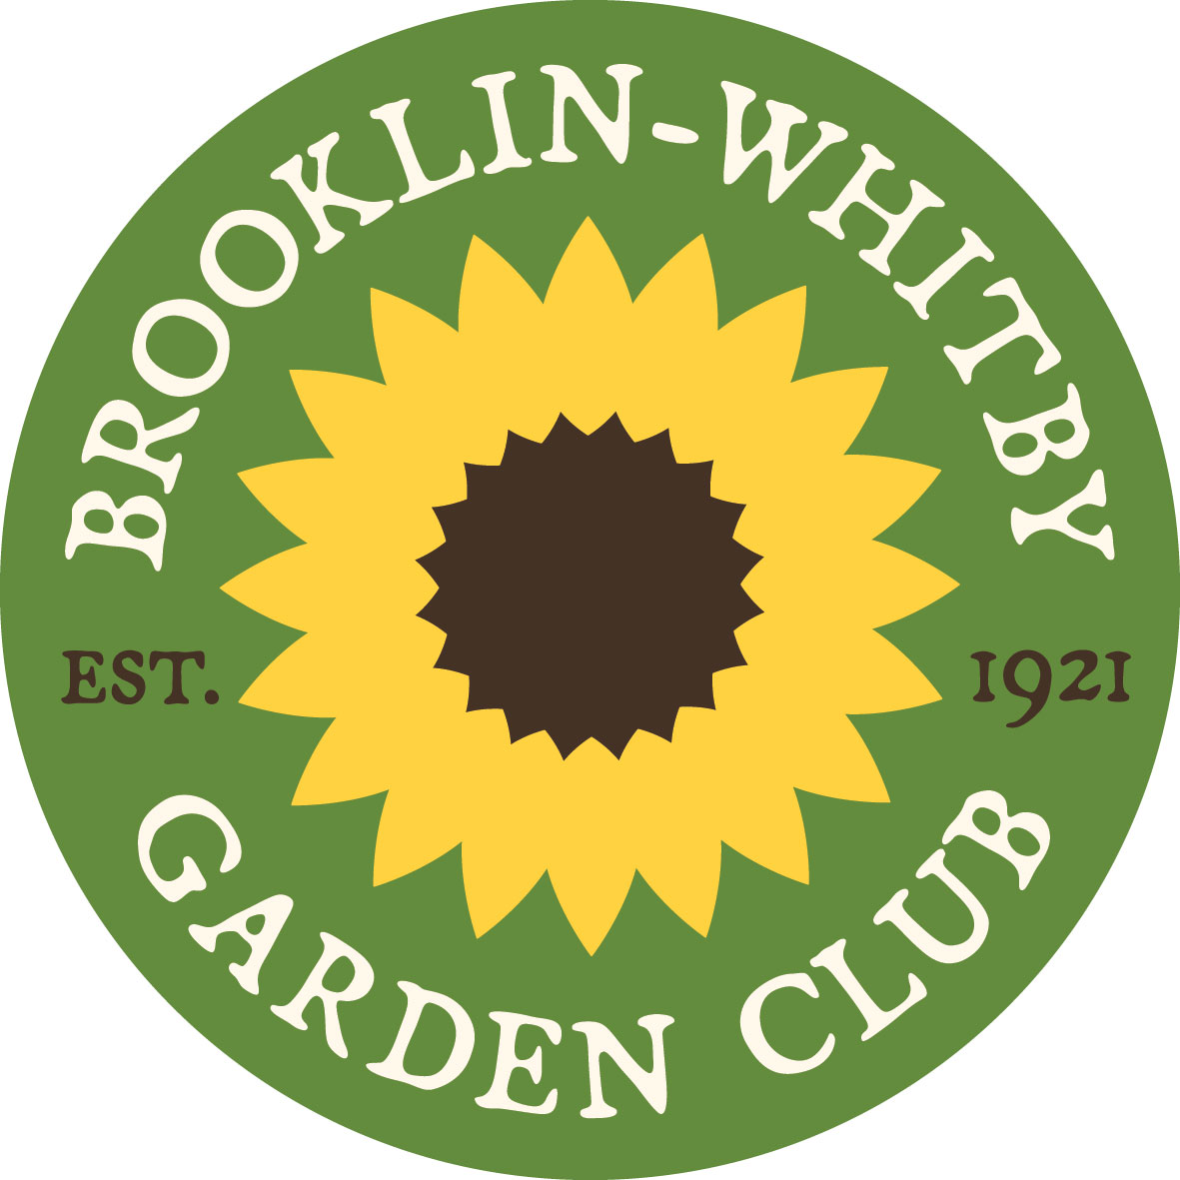

BROOKLIN-WHITBY GARDEN CLUB
www.brooklinwhitbygardenclub.ca

2023 Corporate Membership & Advertising Application

It’s that time of year again when the Brooklin-Whitby Garden club asks our corporate members to renew their support. The form below lists the information that we presently have on file for you. Please review the details shown and update any information that may have changed. We appreciate you support and hope you can continue to support this worthwhile community organization

Business Contact Information
Contact:
Participation Level
Membership & Advertisement* | $40
Advertisement Detail
Please advise if any changes are required. Below is the detail we have on file:
Business Name
Link to Business Website/FB page/ etc.
Business Phone Number
Discount Offer (included on all membership cards) | _____%
Graphics | p Same as last year
 | p New graphic/business card
BWGC Yearbook | p Yes
 | p No
Payment Options
Cheque payable to:  “Brooklin Horticultural Society” | Mail to:  2 Falstaff Cres.  Whitby, ON L1R 1W4 or  Or e-mail to: treasurerbwgc@gmail.com
E-transfer | treasurerbwgc@gmail.com
Confirmation and payment must be received by December 31 to guarantee inclusion of your advertisement in our Yearbook.

*Benefits of Membership & Advertisement participation level:

- Monthly feature of up to 5 Corporate Members on our Facebook page with a ‘shout out’ to the Brooklin-Whitby-Oshawa Business Owners directed to almost 12,000 members.
- A business card sized advertisement usually displayed on the introduction screen at each meeting
- Corporate sponsor member discounts as shown on the back of membership cards
- Access to our regular meetings, including special speakers and shows
- Receive e-mail updates on upcoming events and meeting dates, plus our newsletters
(4 x per year)
- If you send us a note for upcoming events, we will feature the event in our newsletter, publish in October, February, May and August.

